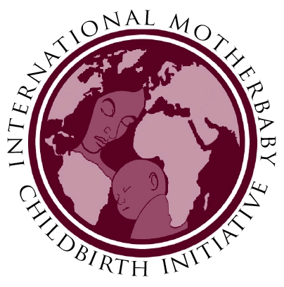International MotherBaby Childbirth Initiative (IMBCI) MotherBaby Network (MBnet) Application

Type of Application
Clinical / Care Provider | Activist / Policy Level

To view examples of Clinical / Care Provider and Activist / Policy Level MBNets click here

Application details: check all that apply

(Clinical / Care Provider ONLY)
Facility | Name:
Organization | Name:
Individual Care Provider | Name:

Application details: check all that apply

(Activist / Policy Level ONLY)
Organization | Name:
Individual Advocate | Name:

Contact Information

(All applicants)
Contact Name
Address
City, State or Province,
ZIP Code
Country
Phone(s) (please include full international codes)
Skype Name
E-Mail Address
Website

General Information

(All applicants)
Briefly describe your service, your organization, and/or your facility.

Describe the population you serve in terms of social and economic status.

Please describe your history in working with and supporting mother and baby friendly childbirth.

Please tell us the three most important reasons for your request to be an MBnet.

Your Mission, Vision, and Goals as an MBnet

(All applicants)
Please state your vision and mission for your MBnet.

Outline your primary goals.

Define the strategies for achieving your goals.

Please describe what you have to share with other MBnetters – experience, materials, projects, activities, skills.

What Kind of Providers Attend Births in Your Region(s)?

(All applicants)
Midwives | Attend approximately % of births
Obstetricians | Attend approximately % of births
Family Physicians | Attend approximately % of births
General Practitioners | Attend approximately % of births
Nurses | Attend approximately % of births
Traditional Birth Attendants/Traditional Midwives | Attend approximately % of births
Others | Attend approximately % of births

Maternal Care Services Available in Your Community (Please Describe)

(All applicants)
Prenatal
Labor/Doula Support
Intrapartal
Childbirth Education
Breastfeeding Education
Postpartum Care
Other

Maternal Care Services Provided (Please Describe)

(Clinical / Care Provider ONLY)
Prenatal
Labor/Doula Support
Intrapartal
Childbirth Education
Breastfeeding Education
Postpartum Care
Other

Data Collection

(Clinical / Care Provider ONLY)
How many births per year?

Two years ago __________ Last year ________ Current year (projected) _________
Current Outcomes:
Normal spontaneous births | Occur %
Labor induction | Occur %
Oxytocin augmentation | Occur %
Operational vaginal deliveries | Occur %
Cesarean sections | Occur %
Elective cesarean | Occur %
Vaginal birth after 1 cesarean | Occur %
Vaginal birth after 2 cesareans | Occur %
Vaginal birth after more than 2 cesareans | Occur %
Epidural | Occur %
Episiotomy | Occur %

Routine Procedures used in Your Facility for “All” healthy Women and Newborns

(Clinical / Care Provider ONLY)
Laboring Women
Intravenous line for women in labor
Continuous electronic monitoring
Systematic rupture of membranes
Episiotomy in nulliparous women
Episiotomy in multiparous women
Vertical (upright) deliveries
Choice of position during childbirth
Maternal restriction of movements during labor
Other _________________________________
______________________________________
______________________________________
Newborns
Skin to skin contact – baby to mother’s chest immediately after birth if possible
Immediate warming and drying
Clean cord care
Delayed cord clamping
Early initiation of breastfeeding
Other _________________________________
______________________________________
______________________________________

Website Paragraph
Please provide one paragraph describing how your MBnet will promote the International MotherBaby Childbirth Initiative for our website at www.imbci.org.

Affirming Your Commitment as an MBnet
Please check each item to confirm that you have done the following:
Read the International MotherBaby Childbirth Initiative in its entirety
Agree with and promote the 10 Steps of the IMBCI
Completed the “Support the IMBCI” form on our website at www.imbci.org
Comply with the WHO International Code of Marketing Breast-milk Substitutes
Comments:

Agreement and Signatures
By submitting this application, I/we affirm that the facts set forth in it are true and complete. I understand that by our own initiative we are confirming support of International MotherBaby Childbirth Initiative (IMBCI) and using it to promote the 10 Steps to Optimal MotherBaby Maternity Services in our own contextual surroundings. We will inform IMBCO of our progress, accomplishments, and setbacks. IMBCO affirms that you will be recognized by IMBCO as being part of the MBnets engaged in the promotion of the IMBCI. As a result, you will have access to IMBCO resources and will have the opportunity to share your victories and/or challenges through the IMBCO website.
Name (printed)
Signature (Digital)
Date
Name (printed)
Signature (Digital)
Date
Name (printed)
Signature (Digital)
Date

IMBCO May 2014

